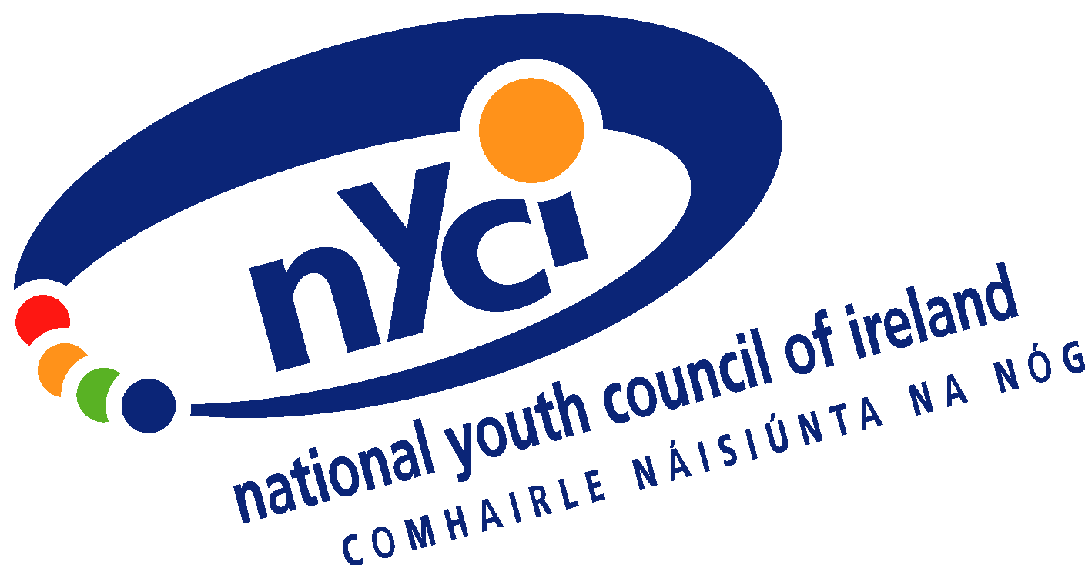

NYCI Submission to the Department of Social Protection on the Implementation of the Youth Guarantee in Ireland

National Youth Council of Ireland

November 2013

Summary of Recommendations:
- National Steering Committee comprising all key stakeholders including representatives of young jobseekers and the youth sector to be chaired by independent person.
- Government to invest significant additional resources over and above €200m announced to implement a comprehensive Youth Guarantee.
- Government should explore financial contribution to Youth Guarantee from employers and philanthropic organisations.
- Clarity on existing places in 2013 required and implementation plan to include budgets and number of new places and opportunities being provided in 2014.
- Ensure diversity of provision to meet diverse needs of young jobseekers.
- Focus on long term unemployed and those not in education, employment or training.
- Innovation fund to support youth sector to engage with most disadvantaged to assist them to progress into mainstream education, training and work experience.
- Increase the number of case workers and ensure high quality guidance and advice.
- Need to put young jobseeker at centre of decision making and ensure they have ownership on personal career plan.
- Local case workers should have discretion and flexibility with regard to placing young jobseekers on programmes and schemes where they do not meet strict criteria.
- Youth Guarantee should be promoted and delivered as an opportunity and sanctions if applied should be the last resort.
- Need to engage with employers so as to meet needs of local labour market.
- Progression into employment is important, but measurement of progression should also include “distance travelled” as some will need more support before securing work.
- Monitoring and evaluation of the initiative should be built in from the start.
- Annual report on all aspects of the Youth Guarantee should be published.
- Annual conference should be organised to review progress and Government should consider European summit as follow up to recent Paris summit.
NYCI Submission to the Department of Social Protection on the Implementation of the Youth Guarantee
Introduction
As one of the first organisations in Ireland to call on Government to explore the feasibility of designing and implementing a Youth Guarantee in February 2011, we welcome the opportunity to contribute to the development of the Irish implementation plan. This submission focuses primarily on what we consider to be the necessary components for the delivery of an effective Youth Guarantee in Ireland.
Key Components of the Youth Guarantee
Governance and Oversight
We note that a key aspect of the Youth Guarantee implementation plan template provided by the European Commission refers to “partnership approaches”. The guarantee cannot be delivered by one Government Department or one agency. It requires collaboration between key Government Departments and a broad range of stakeholders. We recommend the Irish implementation plan includes a commitment that the rolling out of the Irish Youth Guarantee scheme is overseen by a national steering committee made up of the relevant Government Departments, state agencies, young jobseekers, youth organisations, employers and other relevant stakeholders. We propose that this steering group should be chaired by an independent person appointed by Government who is not directly involved in the delivery of the guarantee.
Investment
Eurofound’s research confirmed that not only does youth unemployment impact negatively on young people, their families and communities but that it imposes significant economic costs to society vis a vis earnings forgone and lost revenue. Eurofound estimated that youth disengagement from the labour market costs about 1.2% of GDP in the EU or about €153 billion per annum, or in Ireland about €2 billion per annum. While the investment is significant, failure to invest in such an initiative will result in substantial costs to the exchequer as a result of dependence on the state through social welfare and the cost of long-term disengagement arising from long-term unemployment. Additional resources will be required. Drawing from the Swedish experience of implementing the Youth Guarantee, we know that while the investment per participant is €6,600, after just one year the average net gain for the state per participant in the scheme is just over €4,000 because significant numbers had gained employment. Therefore the short-term investment produces a medium term gain especially in terms of preventing young people from falling into long-term unemployment. Furthermore spending on the existing active labour market should be subject to rigorous and robust evaluation to ensure they are delivering positive outcomes for jobseekers.
The indications from the European Commission that Ireland will receive in the region of €64m from the Youth Employment Initiative and possibly up to €67m from the European Social Fund for the period 2014-2015 is welcome. Even when the Irish exchequer contribution of is included, however, the overall figure for the period 2014-2015 is approximately €200m. Estimates vary but that allocation would be about a third of the monies required to deliver a comprehensive guarantee. Given the many challenges young jobseekers are facing already, we must not create false dawns and over promise and under deliver. The word “guarantee” has a currency in our common parlance. If the Government gives a guarantee and then can’t deliver on it, the overall project will be compromised. We are strongly of the view that the Government should only guarantee what it can deliver to young jobseekers.
Contribution by Employers and Philanthropy
We would urge the Government to engage with employers and/or philanthropic organisations to explore options and encourage investment from employers and philanthropists in the Youth Guarantee. Employers in particular benefit from well trained and job ready employees so it is makes economic sense that they contribute to the initiative. While there may not be sufficient time to explore private sector/philanthropic contributions in 2014, we believe this should be examined for 2015 and beyond.
Education, Training and Work Experience Capacity
We are concerned about the education, training and work experience opportunities currently available to meet the needs of young jobseekers. Clarity on the number of places in the system is required. We estimated back in March 2013 that there are over 48,000 education, training and work experience places for those less than 25 years of age (see appendix). We acknowledge that these figures may not capture all the places available. Government with access to the information should publish a detailed list of programmes, budgets and places currently available for young jobseekers. We must establish what is currently being provided to develop and deliver the additional capacity required to implement the guarantee.
Having clarified what is currently being provided to young jobseekers the Government in the implementation plan must set out in detail the new places being provided on each programme and the associated budget for 2014 and 2015.

Diversity of Provision
Given the diversity of needs of young jobseekers, from the young person with low levels of literacy to the young postgraduate jobseeker, there is a need to ensure that the Youth Guarantee offers a broad suite of options to the young jobseeker across the spectrum. This should include all the current education, training and work experience opportunities and extra provisions such as an enterprise option where the guarantee could provide a business start up grant or loan security.

Reaching the most disadvantaged
We support the implementation of a comprehensive Youth Guarantee that supports all young jobseekers. There has been some debate about where to begin, i.e. to focus on those closest or furthest from the labour market or on the more recently unemployed or the long-term unemployed. This does not need to become an ‘either/or’ dilemma. Instead we favour an approach that would provide different groups with particular needs different types of support.

However an emphasis should be placed on targeting young people who are long-term unemployed, who currently represent about 45% of those on the Live Register. As the OECD report notes, the probability of exiting unemployment for young jobseekers less than twelve months unemployed is 65%, but this falls to 40% for young jobseekers who are unemployed for 12 months or more. All parties need to be aware that working with the long term unemployed can be challenging and progression into employment will take longer than other cohorts for obvious reasons. The youth sector, community and voluntary sector can play a key role in engaging with the most marginalized and disadvantaged youths and the long-term unemployed.
The role of the Youth Sector
We believe that the youth sector and indeed other stakeholders working at community level with young people have an important role to play in reaching and engaging with the most disadvantaged. The OECD have acknowledged the integral role the social sector can play in addressing youth unemployment, although they note that “the sector remains comparatively under utilised in comparison with other European counties”. All the evidence from Ireland and other jurisdictions suggests that young people in this category are distrustful of state and official agencies. We believe that if all the additional resources are channeled through existing state agencies and providers, then it is likely that many of the hardest to reach and long-term unemployed will get left behind. Youth organisations have a good track record of working in local communities and have credibility with young jobseekers and local knowledge to connect with this cohort.

NYCI made a proposal to the Department of Children and Youth Affairs earlier this year suggesting the establishment of a strand within the Youth Guarantee with clear objectives and outcomes to focus particularly on young jobseekers in the NEET category. The proposal recommended the establishment of ‘an innovation fund’ which youth services (as part of local consortia) could access funding to run local initiatives which would serve to support young jobseekers and to be the bridge between them and education, training and work experience opportunities.

Quality Guidance and Job Counselling
The OECD report indicated that Ireland has half the number of case workers per jobseeker than the Nordic countries. We welcome the commitment from Government to increase the number of case workers because many young jobseekers need intensive guidance, job search assistance and job counseling. We believe that the Irish implementation plan must clearly set out the number of case workers who will be assigned to implement the guarantee. Unless there are sufficient numbers then the quality of support and advice will be compromised and it will not be possible to prepare the personal career plans required under the guarantee. It is also vital; however, that we do not just focus on the number of case workers and the number of young jobseekers they meet. It is important that we also focus on the quality of engagement. Such engagement requires feedback from the jobseekers on the support and services provided. We propose an annual survey of jobseekers to get their feedback and to improve the quality of the guidance and counselling.

The Jobseeker at the centre of decision-making
In order to maximise the benefits of the Youth Guarantee, it is crucial that the young jobseeker is actively involved in the decision-making process in relation to their placement. Our consultations with young people suggest they are realistic about what is possible but are concerned about their career path and want to know that education, training and/or work experience will put them on a path to work. If the jobseeker is involved and has ownership over the decisions made they are more likely to be committed and the outcomes will be enhanced. If jobseekers view the offers made under the Youth Guarantee as being imposed without consultation or consideration of their views or needs, then it is more likely to fail. Furthermore places must be allocated on the basis of responding to the needs of the jobseeker and not to reduce numbers on the Live Register or fill a place on a training course.

NYCI acknowledge it will not always be possible to meet the needs of all young jobseekers, however, at the very least they should understand what is being offered and why and how it will enhance their employability. We propose that the personal career plan should include “a reasons why” section which both the jobseeker and case worker sign. This measure will help to clarify the reasons for the key actions in an individual’s plan. It will also ensure that the jobseeker understands the rationale for the plan. NYCI recommends that if a young jobseeker is unhappy with the proposed offer and/or career plan, they should have the right to have the offer reviewed by an independent third party whose decision is binding.

Flexibility and Discretion
The existing range of education, training, work experience and job support schemes are subject to differing eligibility criteria and payments. While we understand that there may be legal, operational and budgetary issues, we would propose that local case officers supporting the implementation of the Youth Guarantee have some level of autonomy and discretion to ensure young people can access programmes. For example in some cases young people may not have spent sufficient time on the Live Register to qualify for a programme. Perhaps in circumstances like this, the case officer would be allowed reduce the waiting period by 50%. If we are to ensure young people can be progressed through the system, it is important that case officers have some discretion and flexibility.
Focus on incentives and not sanctions
The presentation and delivery of the Youth Guarantee must be more ‘carrot than stick.’ To date, the Youth Guarantee has been presented as an opportunity to support young people through the current unemployment crisis. Therefore we must ensure that both the guidance and opportunities provided are of a high quality. While we acknowledge Government policy is to reduce payments to those who do not engage with activation, we believe such sanctions should be a measure of last resort. If we start off by presenting the negatives for lack of participation then a lot of goodwill will be lost. Also the criteria for imposition of reduced payments under the sanction process should be clearly outlined to all young jobseekers at the start in a clear and accessible manner.
Engagement with Employers
We strongly support the view that engagement with employers is a vital component of a successful Youth Guarantee. Most of the commentary in this area, however, appears to focus solely on private sector employers. The community and voluntary sector is a significant employer in Ireland and therefore the potential to create jobs in that sector should also be exploited.

Measuring Success and Progression
For young jobseekers and those working with them, the best result is a job, but ideally a well paid job with long term prospects. We believe that judging the results of the Youth Guarantee on the basis of the number of young people who gain employment is a crude way to measure success and Government should be striving to implement more sophisticated methods of evaluation. For instance we should ascertain the number of young people who gain meaningful work from the initiative. Moving young people from welfare into poorly paid and temporary employment is a short-term solution that is likely to see the young jobseeker return to welfare after a short period. Furthermore if we are to engage with the long-term unemployed, there is a need to understand that the progression from inactivity to work will take longer and the measurement of success should explore ‘distance travelled’, e.g. supporting a young person who left school early into a training programme.
Monitoring and Evaluation
We fully support the recommendation of the OECD that all active labour market programmes should be subject to “systematic, independent, and rigorous evaluation.” Evaluation and monitoring should be incorporated from the start and should not be an after- thought when the programme is well established.
Annual Review
We propose the publication of an annual review of the guarantee at the end of both 2014 and 2015. This should include details on the places, programmes, expenditure, progression, jobseekers and employer surveys and evaluations. It should be possible for the external reader to have a clear overview of the Youth Guarantee initiative from this document.
Annual Conference/European Summit
We propose that the national steering group appointed to oversee the implementation of the guarantee should organise an annual conference to bring key stakeholders together, to share views, perspectives and good practice, to review progress and challenges and to learn from development in other EU member states.
We also suggest that the Irish Government should consider hosting a follow up event to high-level conference on youth unemployment hosted by the French President François Hollande in November 2013. We understand that the Italian Government will be hosting a conference in April 2014. We believe the Irish Government should consider a follow up conference in autumn 2014 or in 2015. This could serve as an opportunity to review the progress on the implementation of the Youth Guarantee in Ireland and the EU and other actions to address youth unemployment across Europe.
Conclusion
We acknowledge that the Youth Guarantee is an ambitious project and will require significant political will, energy, resources and commitment by a range of stakeholders to make it work. Given the scale of the youth unemployment crisis, however, doing nothing is not an option. There is now momentum across Europe on the Youth Guarantee and it represents a great opportunity to give young jobseekers hope and a plan to support them into the labour market. We believe it can make a real difference and are committed to working with all to ensure it succeeds.

Appendix
Education, Training and Work Experience Places (March 2013)
Scheme* | No of places | No of participants under 25 | % participants under 25
Youthreach | 5521 | 5521 | 100
VTOS | 5651 | 945 | 16.7
BTEI | 32320 | 4835 | 15
PLC | 35609 | 24683 | 69
Springboard | 5875 | 370 | 6.3
JobBridge (Nov 13) | 6321 | 1637 | 29
CE | 22548 | 354 | 1.5
Tus | 4446 | 549 | 12.3
BTWEA | 10810 | 312 | 2.9
BTEA | 24914 | 6585 | 26.4
LTI | 2136 | 1015 | 47.5
Momentum | 6500 | 1250 | 19
Total | 162651 | 48056 | 29.5

VTOS Vocational Training Opportunities Scheme
BTEI Back to Education Initiative
PLC Post Leaving Certificate Courses
CE Community Employment
TUS Community Workplace Initiative
BTWEA Back to Work Enterprise Allowance
BTEA Back to Education Allowance
LTI Local Training Initiative

NEETs, Young people not in education, employment or training. Characteristics, costs and policy responses. Eurofound
Getting Youth on the Job Track, OECD. September 2013 P57
Getting Youth on the Job Track, OECD. September 2013 P80
Getting Youth on the Job Track, OECD. September 2013 P68

