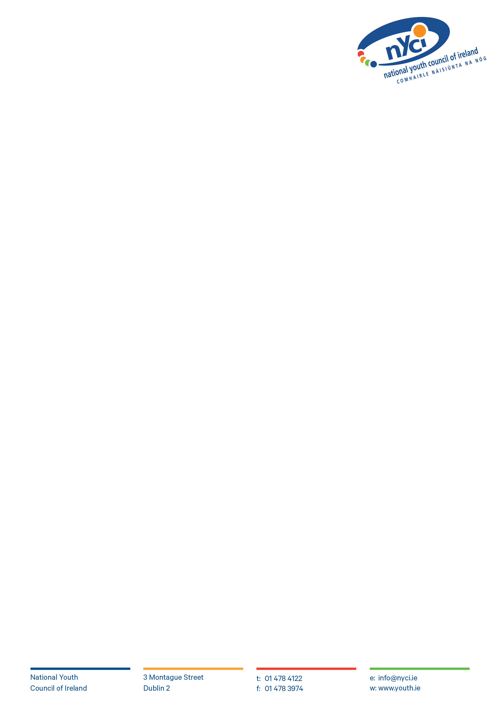**Artist and Youth Work Grant Scheme**

**Template: Planning- What will you do?**

(For Strand 1- Explorer grant , please describe how you plan to develop your collaborative residency programme together with key partners. For Strand 2- full grant, please describe the residency programme which has been agreed by the key partners.)

Include all relevant information including planning meetings, workshops/activities, events, and feedback sessions.

Only projects outlined within the timeframe June- December 2021 will be deemed eligible. They must be within 6 weeks to 6months in duration.

|  |  |  |  |
| --- | --- | --- | --- |
| What? | Where? | Who? | When? |
|  |  |  |  |
|  |  |  |  |
|  |  |  |  |
|  |  |  |  |