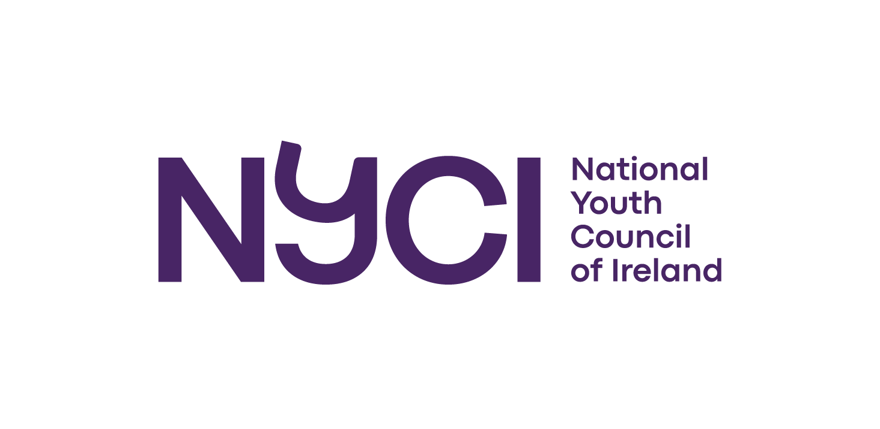

The National Youth Council of Ireland

Request for Tender Proposals for lead facilitator and trainer the EU Youth Dialogue process 2024

with

NYCI’s International Programme

Closing date for receipt of tenders: Tuesday 9th January

NYCI
3 Montague Street
Dublin 2
D02 V327
www.youth.ie
00 353 1 4784122
international@nyci.ie

Introduction

National Youth Council of Ireland
The National Youth Council of Ireland is a national organisation which represents and supports community, voluntary and not for profit youth organisations in Ireland. Founded in 1967, we currently have 55 members across Ireland who represents the scope, scale, and diversity of the youth work sector (www.youth.ie/members). At a conservative estimate, youth organisations influence the lives of almost 400,000 young people in every urban/rural community in Ireland.

NYCI uses our collective experience to act on issues that impact young people. We provide a comprehensive range of advice, information and training programmes including:
- National Youth Health Programme
- National Youth Arts Programme
- Interculturalism and Equality Programme
- International Programme
- Youth 2030 Global Youth Work Programme
- UN Youth Delegate Programme
- Child Protection Programme
- STEAM in Youth Work Programme
- Youth Policy, Research, Media, and Communications

Additionally, we undertake advocacy with policymakers, legislators and funders on behalf of our members to secure an appropriate political, legal and operational environment for youth work in Ireland.

We believe that a fair and just society is one where young people are valued; where there is a commitment to justice; a belief in the interdependence of lives and a sense of solidarity that comes from people acting together; a strong commitment to freedom; and a strong engagement with the ecological values of harmony and balance with nature.

The NYCI International work area aims to facilitate and promote the involvement of youth organisations and young people in international activities and to encourage youth organisations to include an international dimension to their youth work. We advocate and lobby on International and in particular European youth policy to ensure young people have an opportunity to add their voice to decisions that affect young people, their youth organisations and their future. NYCI lead out on the engagement of young people in the EU Youth Dialogue process in Ireland as a member of the National Working Group on EU Youth Dialogue. See www.youth.ie/youngvoices for information and reports from previous consultations in Ireland. For more information on the structured dialogue process at a European level see link: EU Youth Dialogue | European Youth Portal (europa.eu). In Ireland the EU Youth Dialogue process is called Young Voices.
Background to the EU Youth Dialogue Process
What is it?

The EU Youth Dialogue (hereinafter EUYD) is a forum for continuous joint reflection and consultation of young Europeans on the priorities, implementation and follow-up of European cooperation in the field of youth. Next to its specific policy objectives,5 the dialogue supports the implementation of EU youth policy and constitutes the most important and most elaborate youth participation mechanism in policy-making in the Union. This participatory process with young people and youth organisations involves policy and decision makers, as well as experts, researchers and other relevant civil society actors from all over the European Union.

What are the objectives?
The 10th cycle of the EU Youth Dialogue will run from 1 July 2023 until 31 December 2024 under the trio Spain - Belgium - Hungary. In 2010, the same trio envisaged the dialogue for the first time as a ‘Structured Dialogue’ with young Europeans. In 2023-2024, the dialogue will reach its 10th round in which the founding fathers and mothers of the dialogue will team up again. This provides the opportunity to define and develop it further with the ambition to achieve a more comprehensive – and thus more meaningful – exchange between policy / decision-makers and young people in Europe. To celebrate the cycle in an impactful manner, the trio aims to develop concrete tools to give an incentive for quality improvement of the EUYD: increase visibility, accessibility and inclusiveness, as well as striving for more youth participation. This cycle is also an occasion to look back at the achievements and the impact of previous cycles, as well as develop input for quality improvement for the future dialogue.

Aims | Building on the experience of previous cycles and setting the path for the following ones, this cycle aims at:
- Ensuring meaningful and diverse youth engagement throughout the process where young people and youth organisations are involved in the consultation and implementation phases of the process and its outcomes;

- Contributing to the realisation of the ambition of the European Union Youth Strategy 2019-2027 to hold a more diverse and inclusive dialogue between policy / decision-makers and young people, especially those not-listened-to and/or with fewer opportunities in decision-making processes and the implementation of the EU Youth Strategy;

- Celebrating the 10th cycle of the EUYD.
2. Thematic framework
Motto | The motto of the 10th cycle is: “WE NEED YOUTH”.

Thematic framework | The topic of the 10th cycle is European Youth Goal #3 on Inclusive Societies:

Societal challenges | #EYG3-Inclusive Societies aims to enable and ensure the inclusion of all young people in society. Recently, their societal position has been impacted by global crises, such as the Covid-19 pandemic, the climate crisis, as well as the Russian aggression in Ukraine and its ensuing societal and economic impact on European societies, among others. More specifically, in recent years young Europeans identified the following challenges: persistent poverty, social exclusion of minorities and vulnerable youth,9 health problems (such as Covid and mental wellbeing-related problems), access to quality employment and training, the climate crisis, peace and security, migratory flows (and the associated distribution of resources)and the use of new technologies (including artificial intelligence).1
These developments put a strong pressure on social cohesion in European societies and on the situation of young people in particular. Strengthening social inclusion and cohesion contributes to the resilience of European societies and of young people, especially young people with fewer opportunities. Aiming at more inclusive societies offers young people the opportunity to take an active role in tackling new challenges. By reaching out to those from minorities, in rural areas, with a handicap, from a socially vulnerable background, inter alia, the EU youth dialogue partners strive to enable all young people to take an active part in and contribute to the dialogue in the fields impacting their lives.

The NYCI International work area aims to facilitate and promote the involvement of youth organisations and young people in international activities and to encourage youth organisations to include an international dimension to their youth work. We advocate and lobby on International and in particular European youth policy to ensure young people have an opportunity to add their voice to decisions that affect young people, their youth organisations and their future. NYCI lead out on the engagement of young people in the EU Youth Dialogue process in Ireland as a member of the National Working Group on EU Youth Dialogue. See www.youth.ie/youngvoices for information and reports from previous consultations in Ireland. For more information on the structured dialogue process at a European level see link: EU Youth Dialogue | European Youth Portal (europa.eu). In Ireland the EU Youth Dialogue process is called Young Voices.

The Brief
NYCI is seeking tenders for the EU Youth Dialogue lead facilitator and trainer to work with NYCI for engagement of young people in the EU Youth Dialogue process.

Service required: | Lead Facilitator and Trainer
Reporting to: | International Affairs Manager, National Youth Council of Ireland.
Budget: | Applicants should provide a detailed breakdown of costs in their tender proposals, including a daily rate and number of days. The Budget is €21,000.
Starting Date: | Jan - Dec 2024
Profile of  Consultant: | The lead facilitator and trainer must demonstrate:  - the skills, experience and capacity to develop and implement a comprehensive project plan and to ensure the effective and smooth running of the implementation of the project including the appointment and co-ordination of a team of facilitators to work with small groups and to liaison with venues, technical staff and other support staff.  - excellent facilitation and training skills and experience in engaging a group of young people in a project over an extended period.  - the skills, experience and in-depth understanding of working with young people and the methods and approaches which best engage and succeed in ensuring young people’s participation;  - excellent communication, interpersonal and team working skills.  - the skills, experience and capacity to work with the NWG and planning group to plan the consultation phase and next implementation stages of the EU Youth Dialogue process, to funding deadlines.  - the skills, experience and capacity to adapt the guiding questions, provided by the European Steering Committee, for online and face to face consultation.  - Flexibility. The number of days and the day worked each week are subject to change. The project will certainly include weekend and evening work.
Role and Purpose: | Lead facilitator and trainer will engage, facilitate and train young people and facilitators in the EU Youth Dialogue process
Key Outputs: | The work will deliver on the following:  - Attend meetings of the National Working Group and Planning Group;  - Plan, facilitate, MC events and focus groups.  - Develop and deliver training for young people engaged in the process and tools for youth workers/leaders.  - Support and prepare young people prior to EU Youth Conferences and any presentations.  - Maintain on-going liaison and communication with the groups as required throughout the process  - They will provide written information updates to both NYCI and the National Working Group of EUYD as required.  - Convene meetings with staff, facilitators to discuss and brief on methodology being employed during the implementation project, consultations.  - Assist in reporting on the process.  - Assist in funding applications for the process.  - Liaise with policy makers to engage with the process.  Personnel  - Brief/train facilitators and youth facilitators for the implementation project, based on agreed methodologies.  - NYCI is to be consulted and to give permission in any decisions taken before subcontracting during this project.  Logistics and Administration  - Liaise with designers and printers, graphic harvester on promotion material in consultation with the NYCI.  - Disseminate outcomes of the EU Youth Dialogue process.  - Liaise with NYCI communication staff on website, social media and press.  - Identify and organise events and focus groups to take place in 2024.  3 EU Youth Dialogue events.  4 EUYD National Working Group meetings  Briefing EUYD delegates for 2 EUYD Youth Conferences as part of the Irish delegation.  4 Training and Coaching events  2 youth Group meetings.

Proposal Required:
In submitting a short proposal (maximum 4 pages) for providing the services set out in the brief.

The deadline for receipt of completed proposals is 9th Jan 2024. Tender applications should include the subject line ‘EU Youth Dialogue tender for Lead Facilitator and Trainer and be submitted by email to international@nyci.ie

An assessment panel will examine all tenders received. The panel will have to be satisfied that the contracted consultant is suitably qualified and has the knowledge, experience and skills needed for the project, within the timeframe and display good value for money. The Assessment Panel will determine eligibility for this service in accordance with the following criteria:
- A clear understanding of the brief and the context within which the International Programme operates.
- Skills and knowledge required to deliver the service successfully.
- Experience of successful delivery on comparable projects.
- Alignment between the outlined approach and the needs of the International Programme.
- Capacity and resources to deliver the services required within the timeline for the project. Please display a daily rate. The
- Overall costs (NYCI does not commit itself to accepting the lowest of any tender. Once the tender has been accepted, any price increases during the term of contract will not be accepted).

NYCI reserves the right not to award the tender to any of the applications received.

Queries
Please contact Jean-Marie Cullen at international@nyci.ie.

