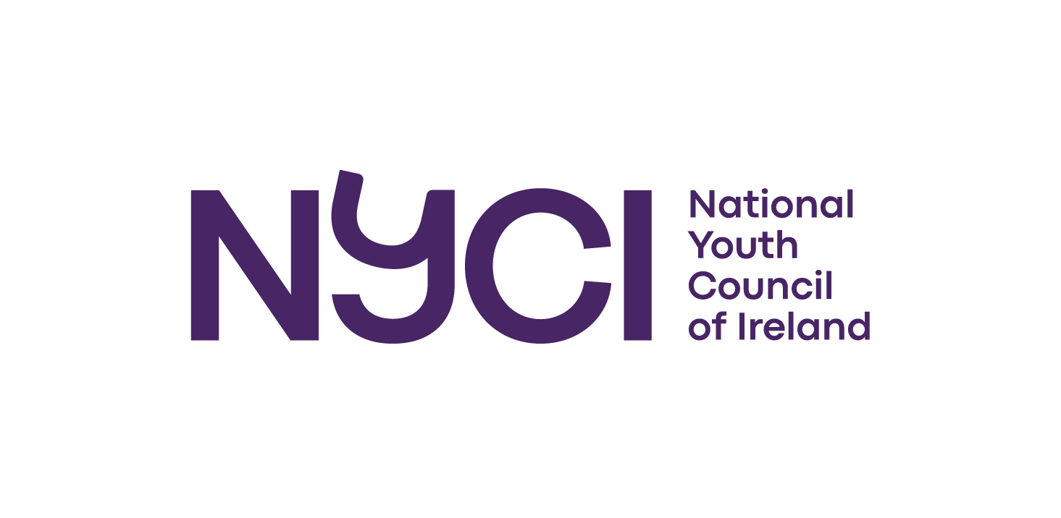
The National Youth Council of Ireland

Request for Tender Proposals for Specialist Services

to work with

NYCI’s Youth 2030
Global Youth Work Programme

to

Evaluate the Maynooth University NUI Certificate in
Global Youth Work and Development Education.

Closing date for receipt of tenders: 23 August 2023

NYCI
3 Montague Street
Dublin 2
D02 V327
www.youth.ie
00 353 1 4784122
valerie@nyci.ie
Introduction
The National Youth Council of Ireland is a national umbrella organisation which represents and supports community, voluntary and not for profit youth organisations in Ireland. Founded in 1967, we currently have 53 members across Ireland who represents the scope, scale and diversity of the youth work sector (www.youth.ie/members). At a conservative estimate, youth organisations influence the lives of almost 400,000 young people in every urban/rural community in Ireland.

NYCI uses our collective experience to act on issues that impact on young people. We provide a comprehensive range of advice, information and training programmes including:
- National Youth Health Programme
- National Youth Arts Programme
- Interculturalism and Equality Programme
- International Programme
- Youth 2030 Global Youth Work Programme
- Child Protection Programme
- STEAM in Youth Work Programme
- Youth Policy, Research, Media, and Communications

Additionally, we undertake advocacy with policy makers, legislators and funders on behalf of our membership to secure an appropriate political, legal and operational environment for youth work in Ireland.

NYCI works in partnership with other local, national and European organisations and institutions to deliver strong outcomes and results that positively impact and support young people in Ireland and internationally. The National Youth Council of Ireland is a registered charity and currently has 34 employees.

We believe that a fair and just society is one where young people are valued; where there is a commitment to justice; a belief in the interdependence of lives and a sense of solidarity that comes from people acting together; a strong commitment to freedom; and a strong engagement with the ecological values of harmony and balance with nature.

The Youth 2030 Global Youth Work Programme is a Global Citizenship Strategic Partnership Programme for the Youth Sector in Ireland.

The National Youth Council of Ireland (www.youth.ie) is the lead partner in the consortium, which also includes Concern Worldwide | International humanitarian & development organisation, Trócaire - Together for a Just World (trocaire.org), and the Centre for Youth Research and Development | Maynooth University

The overall goal of the Youth 2030 Global Youth Work Programme is that:

Young People are informed, skilled and engaged as Global Citizens through Global Youth Work, challenging injustice, inequality, and climate change, in solidarity with the world’s left behind.

- The Brief
NYCI is seeking tenders from qualified people to independently evaluate the Maynooth University NUI Certificate in Global Youth Work and Development Education, which is a Level 8, Special Purpose award delivered in partnership by the National Youth Council of Ireland and the Centre for Youth Research and Development at the Department of Applied Social Studies in Maynooth University.
Applicants are invited to outline their approach and framework they propose to employ to undertake this work.
Service required: | Completed evaluation of the Maynooth University NUI Certificate in Global Youth Work and Development Education, a Level 8, Special Purpose award delivered in partnership by the National Youth Council of Ireland and the Centre for Youth Research and Development at the Department of Applied Social Studies in Maynooth University.
Reporting to: | Youth 2030 Global Youth Work Manager, National Youth Council of Ireland.
Starting Date: | Start: September 1st 2023. The review should be completed by November 24th 2023. Applicants should provide a detailed timetable for completion of the report.
Budget: | €5,000 max inclusive of VAT and this should include all costs such as fees, administration costs and expenses incurred. Applicants should provide a detailed breakdown of costs in their tender proposals.
Payment: | A payment schedule will be agreed with the successful applicant. Payments will be made within 28 days of receipt of an invoice. If at any stage during the evaluation, the agreed level of quality of the work is not adhered to, payment may be withheld.
Profile of  Consultant: | Applications should include:  - An outline of the methods/approach the applicant would take with this piece of work with a general timeline outlined.  - A statement outlining relevant knowledge and skills demonstrated with examples of roles played in comparable projects.  - CV.  - Costs for entire piece of work (including daily rates and anticipated expenses).  - Two referees (including telephone numbers and email addresses).  - Details of any other relevant information that the applicant considers appropriate.  - Tax Clearance Access Code and Tax Reference Number.  - Disclosures of any conflict of interest.  - Contact information.
Role and Purpose: | The Maynooth University NUI Certificate in Global Youth Work and Development Education is a Level 8, Special Purpose award delivered in partnership by the National Youth Council of Ireland and the Centre for Youth Research and Development at the Department of Applied Social Studies in Maynooth University. Aimed at those working in the youth sector, this programme is of interest to those looking to develop knowledge, skills, and competence in the areas of global youth work and development education practice in youth settings.  The Contractor will be required to work alongside Youth 2030 GYW staff to evaluate the Certificate in Global Youth Work and Development Education.  - Review Certificate documentation and delivery (2021 and 2022).  - Undertake interviews/focus groups with previous Cert participants (30 people have graduated from the Level 8 Certificate course), and Consortium partners including NYCI and Maynooth University (Youth Research and Development Unit) who partner on course delivery.  - Hold agreed meetings with Youth 2030 Consortium members.  - Complete the final evaluation report with actionable recommendations by November 24th 2023 with the final document provided to NYCI to publishable standards.

Application process:
The deadline for receipt of completed proposals is Wednesday 23rd August 2023 before 12.00 pm. Tender applications should include the subject line ‘Cert Evaluation Tender’ and be submitted by email to valerie@nyci.ie

Applications submitted before 12.00pm on Wednesday 23rd August 2023 will be acknowledged by email. If an applicant has not received an email confirming receipt of their application, this may indicate the application has not been received and the applicant should follow up with NYCI before the closing date for applications.

An assessment panel will examine all tenders received. The panel will have to be satisfied that the contracted consultant is suitably qualified and has the knowledge, experience and skills needed for the project, within the timeframe and budget outlined above. The Assessment Panel will determine eligibility for this service in accordance with the following criteria:
- A clear understanding of the brief and the context within which the Youth 2030 Programme operates.
- Skills and knowledge required to deliver the service successfully.
- Experience of successful delivery on comparable projects.
- Alignment between the outlined approach and the needs of the Youth 2030 Programme.
- Capacity and resources to deliver the services required within the available budget and timeline for the project.
- Overall costs (NYCI does not commit itself to accepting the lowest of any tender. Once the tender has been accepted, any price increases during the term of contract will not be accepted).

NYCI reserves the right not to award the tender to any of the applications received.

Queries
Please contact Valerie Duffy at valerie@nyci.ie.

