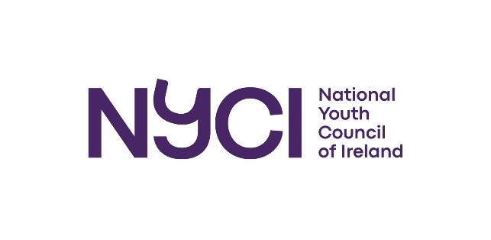

STEAM in Youth Work

Invitation to tender
Independent evaluation of the STEAM in Youth Work Programme

Issued by:
National Youth Council of Ireland, 3 Montague Street, Dublin 2, D02 V327

Deadline for proposal submission:
Thursday 7th of September 2023

August 2023

CONTENTS
1. Introduction and background 2
1.1 About NYCI 2
1.2 About STEAM in Youth Work 2
2. Details of tender 3
3. Timeframe 4
4. Ethnical, consent & confidentiality procedures 5
5. Roles & responsibilities 5
6. Ownership of the information and final report 5
7. Budget and finances 5
8. Your tender submission and selection criteria 5
9. Queries 6
Appendix 1: Project activities and success criteria 7

Introduction and background
The National Youth Council of Ireland (NYCI) invites tenders from individuals/organisations with the expertise needed to design, develop and implement a robust project learning and evaluation framework for STEAM in Youth Work.

1.1 About NYCI
The National Youth Council of Ireland (NYCI) is a membership led umbrella organisation that represents and supports the interests of voluntary youth organisations working with over 380,000 young people in Ireland. We use our collective experience to act on issues that impact on young people. We provide a comprehensive range of advice, information and training programmes nationally. Additionally, we undertake advocacy with policy makers, legislators and funders on behalf of our membership to secure an appropriate political, legal and operational environment for youth work in Ireland. NYCI delivers a range of training and support programmes for youth work organisations, including STEAM engagement, youth health, child protection, international, development education, youth arts, equalities and intercultural programmes.

1.2 About STEAM in Youth Work
STEAM in Youth Work is a two-year programme that aims to deepen the capacity of the youth work sector to:
      - use STEAM within youth work practice to improve the lives of young people.
      - deliver inspiring, hands-on STEAM education and public engagement (EPE) projects in a sustainable manner.

With 382,600 young people, 40,000 volunteers and 1,400 professional staff, the sector is emerging as a key player within Ireland’s STEAM engagement ecosystem, particularly so for its capacity to engage meaningfully with young people from groups or backgrounds that are underrepresented in STEAM education and careers.

Youth work provides one of the few settings where young people, as active partners, can take responsibility for co-creating programmes in a safe and supportive environment. It is therefore ideally positioned to support a STEAM programme which fosters engagement, curiosity and conversation amongst a significant cohort who may not typically engage with STEAM.

Through training, continuous professional development programmes, 13 partnership projects with frontline organisations, resource and equipment dissemination, youth workers will:

- Co-create STEAM projects with young people to respond to current social and environmental issues of concern to them or their scientific and/or creative interests.
- Deliver education programmes that fuse different STEAM topics, for example, Science with Art, Engineering with Maths etc...
- Use innovative blended youth work methodologies, which NYCI has supported the sector’s development of, during and post Covid-19.

1112 training/development opportunities will enable 189 practitioners to deliver in-depth STEAM EPE projects to 9,450 young people within two years. Robust evaluation mechanisms and learning dissemination events will ensure high-quality, transferable, evidence-based and sustainable STEAM EPE practice. NYCI has received €300,000 from the Science Foundation of Ireland to deliver this project over two years (2023 - 2024). It builds on learning from three previous iterations of STEAM in Youthwork (2017 – 2022), which provided training, support, resources and equipment grants to enable 542 youth workers to deliver 1,303 inclusive STEAM engagement activities with diverse groups of up to 20,710 young people.
Further details about the project activities and success criteria are included in Appendix 1.

2. Details of tender
NYCI is seeking an Independent Evaluator on a consultancy basis from October 2023 until December 2024 (with a possibility to extend for a further three months to end of March 2025) to evaluate the impact of STEAM in Youth Work. The Independent Evaluator will design, implement and report on a comprehensive learning and evaluation framework for the project with support from the project team. More specifically, NYCI envisages that the Independent Evaluator will undertake the following tasks:
Establishing the learning and evaluation framework
1. Review and develop the project results framework, logic model, work plan and log frame.
2. Further develop an evaluation and learning methodology for the project, and associated tools for data collection, storage and analysis; ensure the framework and tools are aligned with NYCI’s organisational monitoring and evaluation system.
3. Train 2 - 3 staff members on the evaluation and learning methodology for the project, and on the use of the data collection tools.
Ongoing support
4. Respond to any learning and evaluation issues that arise during the implementation of the learning and evaluation framework.
5. Support the project team to produce 3 – 4 periodic evaluation reports, including an interim evaluation report (where samples of data are pulled, analysed and reported on for the expert advisory group’s four remaining meetings).
Interim and Final evaluation report
6. Undertake data analysis and complete an interim evaluation report by March 2024
7. Undertake data analysis and complete final learning and evaluation report and an accompanying executive summary with key findings, conclusions and recommendations. The final report and the executive summary should be provided to NYCI to publishable standards.

3. Timeframe*
- NYCI’s STEAM in Youth Work project began in August 2023.
- An interim evaluation report will be ready by end of January 2024.
- Services provided through STEAM in Youth Work will conclude by mid-November 2024.
- The first draft of the final evaluation report will be ready by early December 2024.
- The final draft of the final evaluation report will be ready by 21st January 2025.
- NYCI will submit its final report to the Science Foundation of Ireland by early February 2025

It is hoped that the Independent Evaluator would start work on the project from early October 2023.

*Pending approval of extension of project the timeframe may change, but this can be discussed in further detail once initial agreement is in place.

Ethnical, consent & confidentiality procedures
Applicants should outline how they propose to comply with research ethics standards and child protection guidelines.

5. Roles & responsibilities
The successful applicant will be responsible for accessing evaluation participants, undertaking the evaluation research and producing the final report and executive summary, developed to publishable standards. NYCI will introduce the Independent Evaluator to participants and provide support in accessing participants.

6. Ownership of the information and final report
Ownership of data and reports related to the project will reside with NYCI.

7. Budget and finances
The maximum budget for the work of the Independent Evaluator is €17,500 inclusive of VAT. This sum should cover all costs including the Independent Evaluator’s time, reasonable, receipted expenses related to the execution of the above tasks, institutional fees, administration costs etc. Applicants should provide a detailed breakdown of costs in their tender proposals. The successful applicant will need to provide a tax clearance access code and tax number. A payment schedule will be agreed with the successful applicant with instalments being paid on signing the contract, on receipt of the interim evaluation report and on receipt of the final evaluation report. Payments will be made within 28 days of receipt of an invoice. If at any stage during the project, the agreed level of quality of the evaluation research is not adhered to, payment may be withheld.

8. Your tender submission and selection criteria
Tender submissions should include:
- An outline of the methods/approach the applicant would take with this piece of work with a general timeline.
- A statement outlining relevant knowledge and skills demonstrated with examples of roles played in comparable projects.
- CV.
- Costs for entire piece of work (including daily rates and anticipated expenses).
- Two referees (including telephone numbers and email addresses).
- Details of any other relevant information that the applicant considers appropriate.
- Tax Clearance Access Code and Tax Number.
- Disclosures of any conflict of interest.
- Contact information.

An assessment panel will examine all tenders received. The panel will have to be satisfied that the contracted consultant is suitably qualified and has the knowledge, experience and skills needed to successfully design, deliver and report on the learning and evaluation framework for the project, within the timeframe and budget outlined above. The Assessment Panel will determine eligibility for this service in accordance with the following criteria:
- A clear understanding of the brief and the context within which the STEAM in Youth Work project operates.
- Skills and knowledge required to deliver the service successfully.
- Experience of successful delivery on comparable projects.
- Alignment between the outlined approach and the evaluation and learning needs of the STEAM in Youth work project.
- Capacity and resources to deliver the services required within the available budget and timeline for the project.
- Overall costs (NYCI does not commit itself to accepting the lowest of any tender. Once the tender has been accepted, any price increases during the term of contract will not be accepted).

All proposals must be emailed to mollyrose@nyci.ie by Thursday 7th September 2023, 12pm. NYCI may invite applicants for interview on the morning of or at some other time during the week beginning 11th September 2023.

NYCI reserves the right not to award the tender to any of the applications received.

9. Queries
For any queries, please contact Orla Matthews orla@nyci.ie

Appendix 1: Project activities and success criteria

WHAT DOES SUCCESS LOOK LIKE? OUTCOMES, METRICS AND MARKERS

1. Frontline STEAM Partnership Projects:
13 Youth workers demonstrate enhanced abilities to co-create, deliver and evaluate in-depth STEAM Education and Public engagement (EPE) projects and advanced STEAM communication skills (*i.e. understanding of science, ability to inspire young people's curiosity in science, youth facilitation skills that are exploratory, inquiry-based and which support scientific approaches).

234 young people demonstrate development of a range personal/social skills and STEAM competencies (e.g., critical thinking, problem-solving, science capital).

13 local communities demonstrate greater awareness about issues of social, environmental concern,
scientific or creative interest to local youth groups.
Potential Impacts: Increased and enhanced use of STEAM within Youth Work.

2. STEAM Toolkits and Tutorials:
50 youth workers demonstrate self-perceived improved STEAM communication skills and abilities to
deliver hands-on, inspirational STEAM EPE. 1,000 young people experience fun, hands-on STEAM EPE in settings where they would otherwise have limited access.
Potential impacts: STEAM in youth work is an established and well-resourced practice in the sector.

3. STEAM within Youth Work Degrees:
100 youth work students demonstrate self-perceived improved understanding of the relevance of
STEAM to youth work; basic skills in delivering STEAM EPE activities and abilities to use STEAM to
support youth work outcomes. 250 young people experience fun, hands-on STEAM EPE in settings where they would otherwise have limited access.
Potential impact: STEAM becomes embedded in pre-service youth worker education.

4. Supporting Engaged Research:
EPE staff from six SFI-funded or other research/innovation centres demonstrate self-perceived greater understanding/practice of inclusion in STEAM EPE through partnerships with youth organisations.
Potential impacts: More inclusive research/innovation centre EPE programmes, reaching more disadvantaged young people.

5. Showcase Event and Final Learning Report:
20 youth workers and 100 young people demonstrate self-perceived development of a range of
personal/social skills and STEAM competencies (e.g., communication, collaboration, using ICT to
showcase work). Increased sharing and showcasing of inspiring STEAM in youth work among youth workers and young people.
Potential impacts: Showcasing STEAM in Youth Work is commonplace, providing opportunities for
networking, practice sharing for youth workers and skills development and confidence building for young people.

STEAM in Youth Work is funded by the Science Foundation of Ireland.

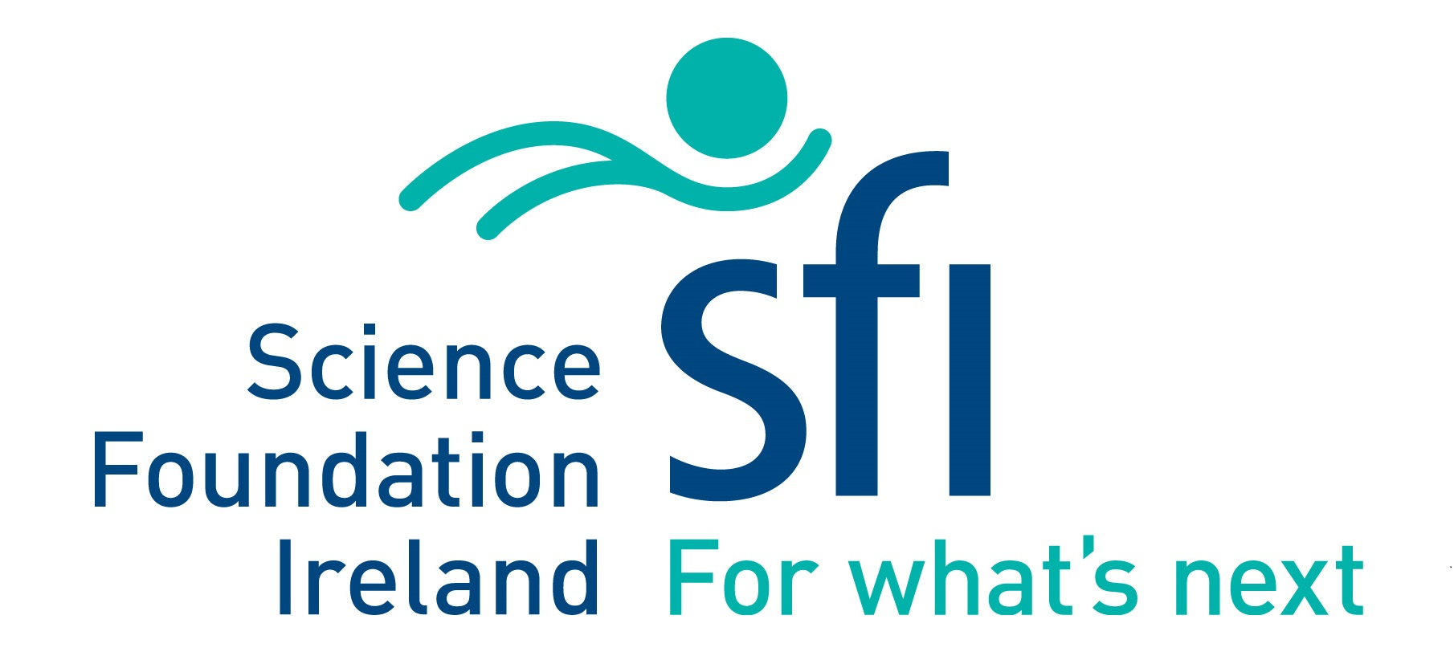 | 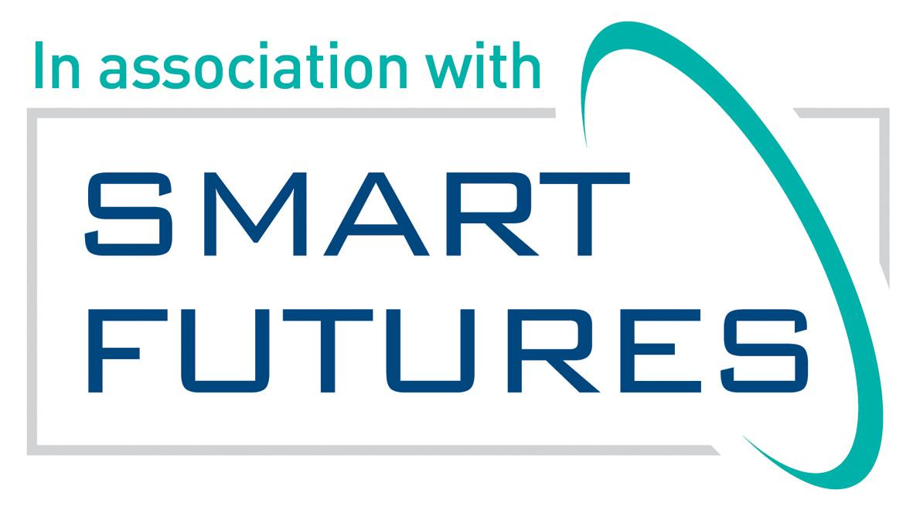

STEAM is Science, Technology, Engineering, Art and Maths.

