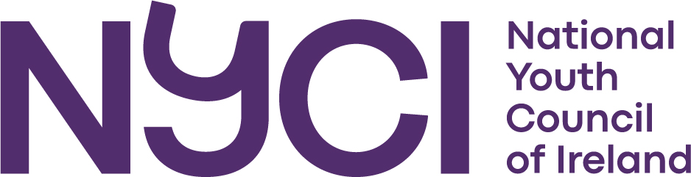

Invitation to Tender

To conduct Research on the Profile and Experiences of Minority Ethnic Youth Workers and Volunteers working in the Irish Youth Work Sector

National Youth Council of Ireland

August 2022

Invitation to submit proposals
The National Youth Council of Ireland (NYCI) is the representative body for voluntary youth organisations in Ireland. NYCI functions to represent the interests of young people and youth organisations. NYCI's role is recognised in legislation (Youth Work Act) and as a social partner. The NYCI aims through its member organisations and its representative role to empower young people to participate in society as fulfilled confident individuals. The work of the Youth Council is based on principles of equality, social justice and equal participation for all. In achieving these aims the NYCI seeks the emergence of a society in which young people are valued citizens who can make a meaningful contribution to their community.

Background and Research Rationale
Ethnic diversity is increasingly reflected within the youth work sector in Ireland. However, there is a dearth of research on the profile and experience of minority ethnic youth workers and volunteers working in the Irish youth work sector. A study of this nature is important for many reasons; it provides an evidence base to inform the development of youth work policy and practice in Ireland.

Research Aim
In undertaking this study, the research should explore the following research questions:

1. What proportion of youth work graduates in Ireland are from a minority ethnic background?

2. What proportion of minority ethnic youth work graduates pursue a career in the youth work sector post-graduation?

3. What is/was their experience of working in the youth work sector in Ireland?

4. Have they experienced challenges working as a youth worker because of their ethnicity?

5. Based on their experience of working/volunteering in youth work, what recommendations would they propose to encourage those from ethnic minorities to pursue a career in youth work?

Research Methodology
Applicants are invited to outline the research methods and sampling techniques they intend to employ to conduct this study and to demonstrate their knowledge of appropriate research methods to fulfil the brief outlined above.

Timeframe
The research should be completed by 13th January 2023. Applicants should provide a detailed timetable for completion of the research.

Profile of Researchers and Relevant Experience
Applications should include a profile of all personnel to be involved in undertaking the research. This should include a detailed CV of the candidate, demonstrating their experience of undertaking similar studies and including two references.
Ethical, Consent & Confidentiality Procedures
Applicants should outline how they propose to comply with research ethics standards and child protection guidelines.

Roles & Responsibilities
The successful applicant will be responsible for accessing research participants, undertaking the research and producing the final report, developed to publishable standards.

Ownership of the information and final report
Ownership of data and reports related to the project will reside with the National Youth Council of Ireland.

Budget
The maximum budget for this project is €10,000 inclusive of VAT and this should include all costs such as institutional fees, administration costs and expenses incurred.

Applicants should provide a detailed breakdown of costs.

Payment
A payment schedule will be agreed with the successful applicant. The following schedule is proposed:
- 30% to be paid on signing the contract.
- 30% to be paid on receipt of intermediate report.
- 40% to be paid on receipt of full research report
Payments will be made within 28 days of receipt of an invoice. If at any stage during the research, the agreed level of quality of the research is not adhered to, payment may be withheld.

Application process:
The deadline for receipt of completed proposals is 1.00 pm on Monday 12th September 2022.
Tender applications should include the subject line ‘NYCI Minority Ethnic Youth Work Research Tender’ and be submitted by email to mollyrose@nyci.ie
You will receive an acknowledgement confirming receipt of your application.

NYCI encourages minority ethnic researchers to apply.

